**Shipping Method Configuration**

**Step1:** Login to Magento2 backend / admin section

**Step2:** Click on Stores -> Configuration

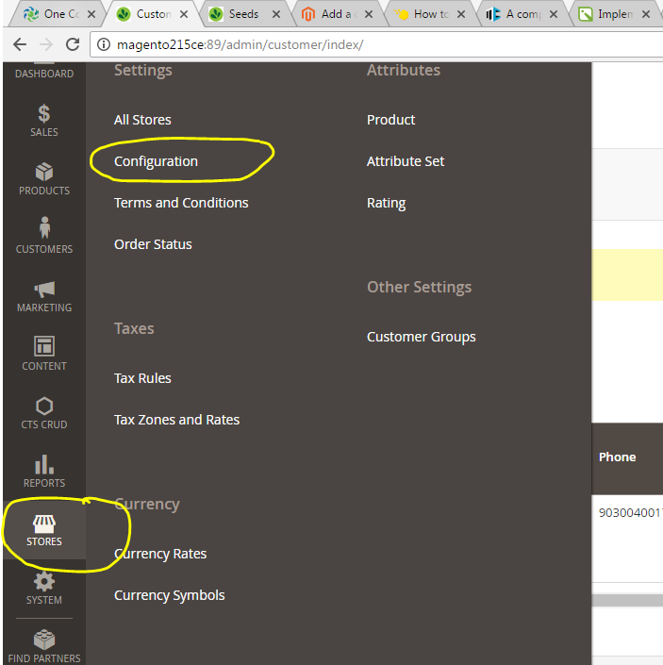

**Step3:** Click on Sales -> Shipping Methods

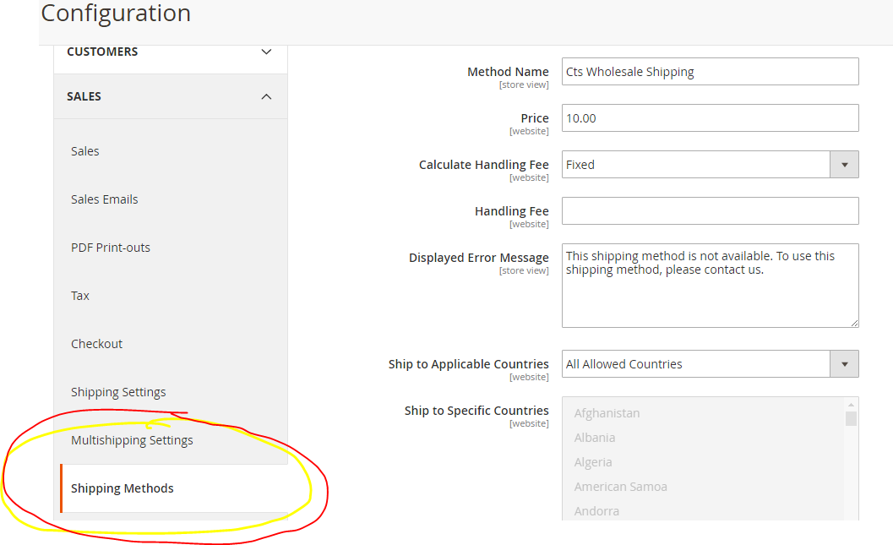

**Step4:** You will be navigated to shipping methods page. Click on the shipping method you wanted to configure.

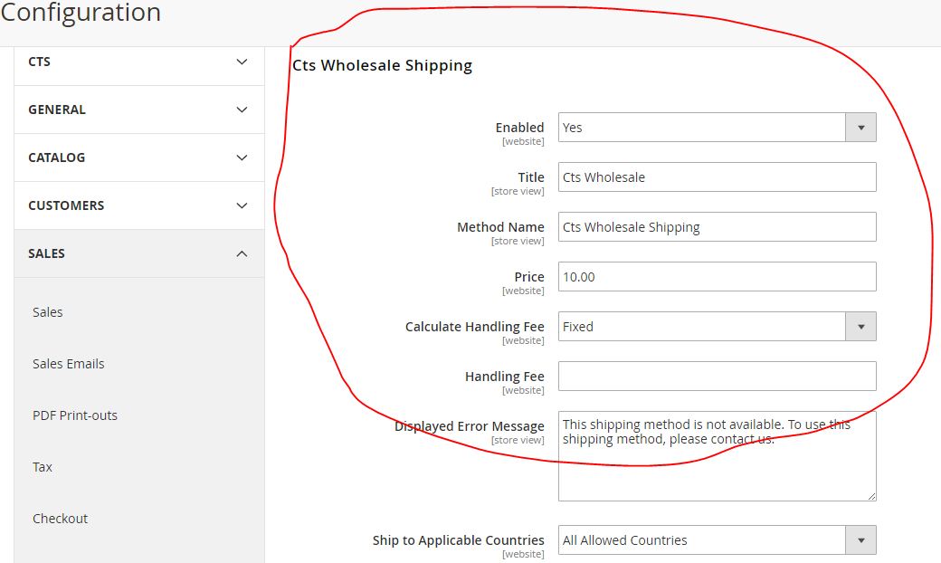

Configure the options available like Enabled, Price, Title, Method name, then click on **Save Config** at the top right corner. Configured Shipping method will be available at order checkout shipping methods.

**Placing an order from MBO**

**Step1:** Click on **Sales->Orders**, it will navigate to Orders grid page. At the top right corner, you will find a button called **Create New Order,** Click on it

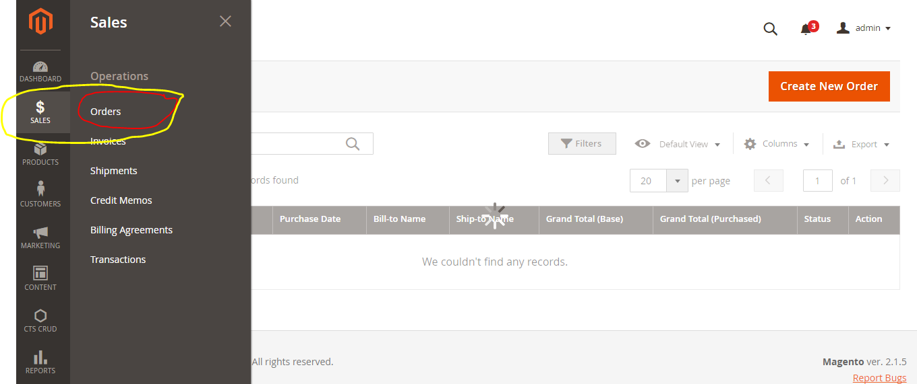

**Step2:** It will navigate to customer grid, here you have to select a customer or you can create a new customer to this order. If wanted to place an order to an existing customer, please select the customer from the list displayed. If you wanted to Create a new customer for the order click on **Create New Customer** button at the top right corner.

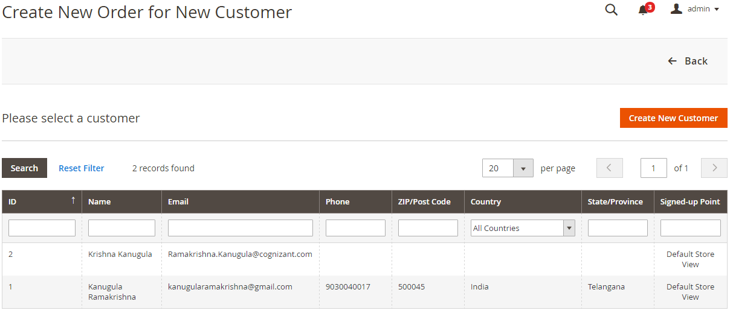

**Step3:** Select the store view to which you wanted to place an order

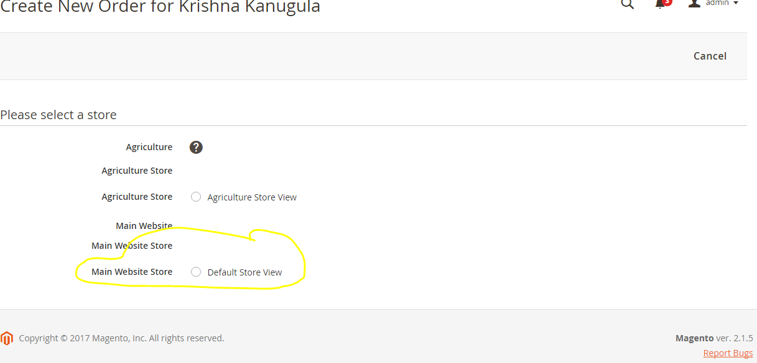

**Step4:** Click on the **Add Products** Button. It will display the available products of the store view. Select checkboxes of the products which you wanted to add to cart

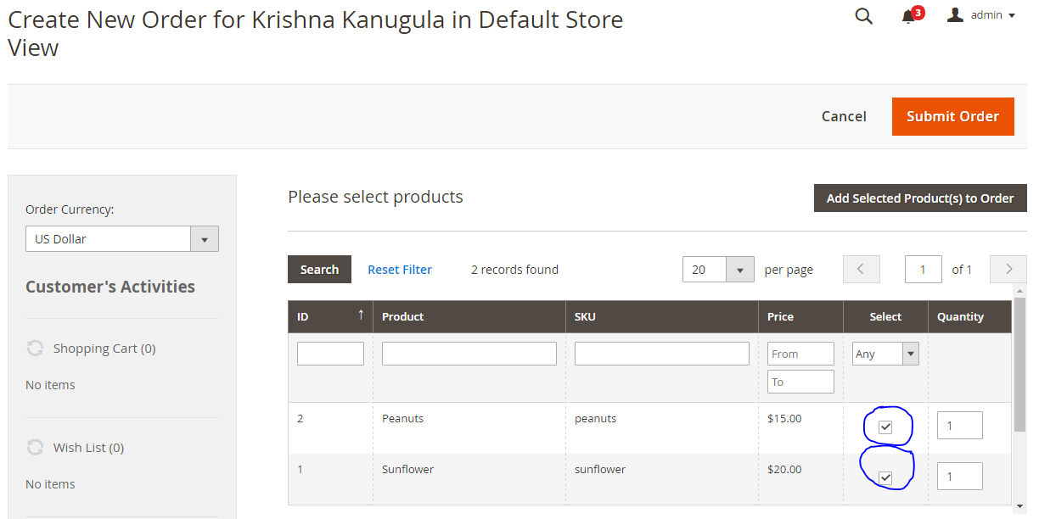

**Step5:** Scroll down and fill the account related details (Billing and shipping addresses)

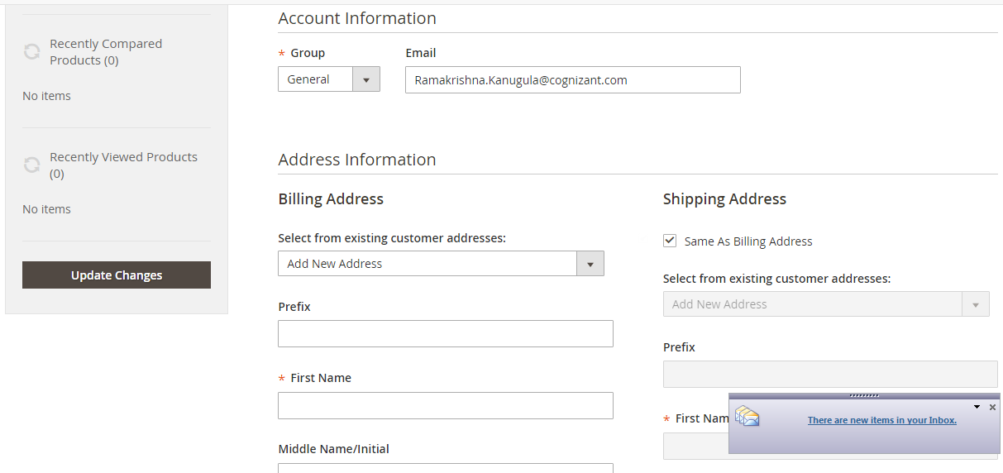

**Step6:** Select the **Shipping and payment** methods and click on place order to place order. Here we get the shipping methods we have configured earlier.

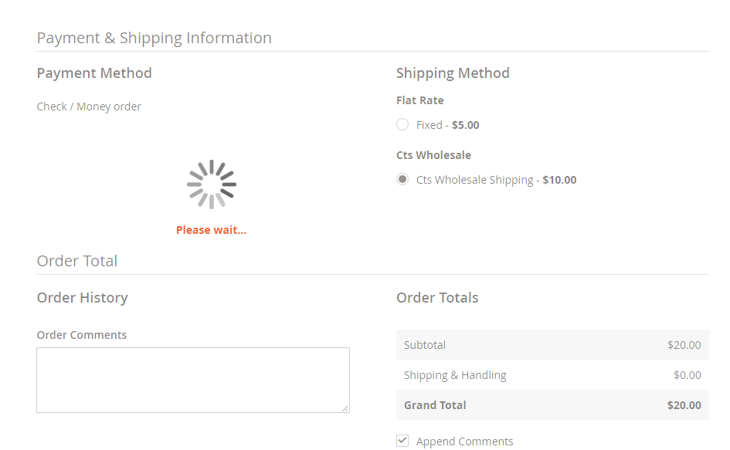

**Step7:** That’s it. We are done with placing order from MBO. After placing order we can generate invoices, credit memos, delivery receipts.

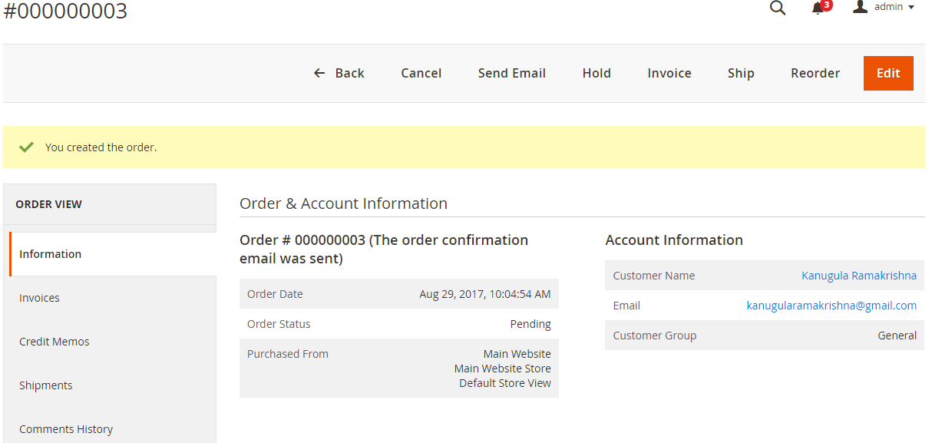

**Step8: Create Invoice**

Click on the Invoice tab on the top menu and scroll down to check the information

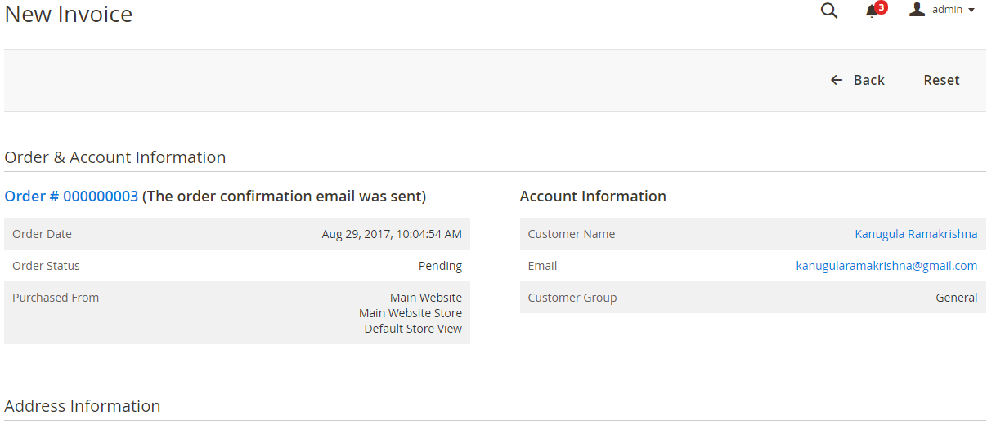

Check the Billing and shipping info

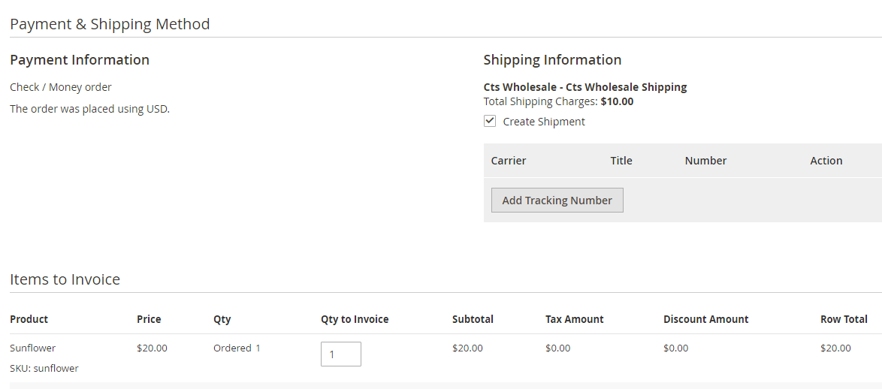

Submit the invoice

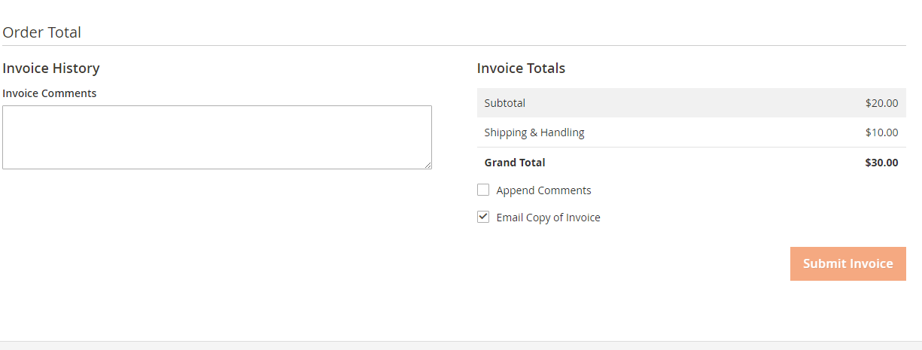

**Payment Methods Configuration**

**Step1:** Login to Magento2 backend / admin section

**Step2:** Click on Stores -> Configuration



**Step3:** Click on Sales -> Payment Methods

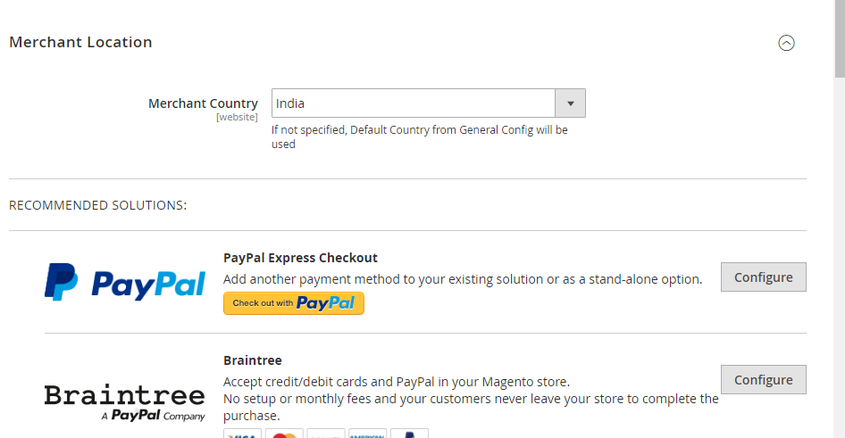

It will display all the available payment methods. Please click on the payment method to expand.

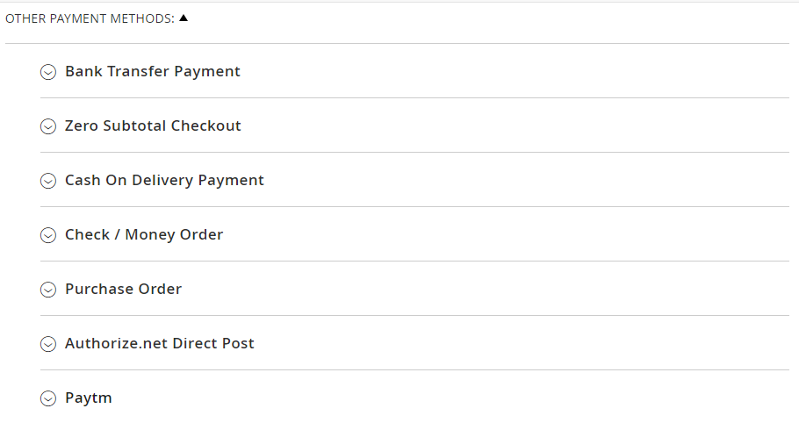

Once the Payment method is expanded fill the details related to the payment gateway like below screen.

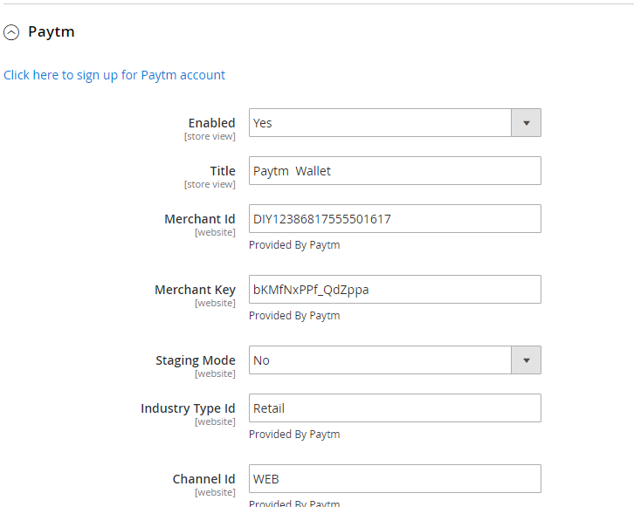

**Click on Save Config** button. That’s it, we are done. Payment method configuration is done.